PCM System Design & Analysis Project Report

Presented by:
Mario Makhlouta A2220007
Antoine Marie Lahoud A2220266
Miguel Nawfal A2212183

Presented to:
Dr. Olga Yaacoub

Telecommunication Lab

Faculty of Engineering
University of Balamand
Contents
Figures 2
1. Introduction 3
2. Objective 3
3. PCM Theory 3
4. PCM System Overview 4
5. Design Specifications 5
6. Simulink Implementation 6
7. Results and Discussion 9
8. Quantization Noise Analysis 15
9. Performance Evaluation 16
10. Advantages and Disadvantages 17
11. Future Work 17
12. Conclusion 18

Figures
Figure 1: PCM System Overview 5
Figure 2: Simulink Solution 8
Figure 3: Input Signal 9
Figure 4: Sampled Signal 10
Figure 5: Quantized Signal 11
Figure 6: PCM Bits 12
Figure 7: DAC Output 13
Figure 8: Reconstructed Signal 14
Figure 9: Input vs Reconstructed 15

1. Introduction
Digital communication systems convert analog signals into digital form for reliable transmission. Unlike analog communication, which uses continuous signals, digital communication represents information using discrete values (0 and 1).
Pulse Code Modulation (PCM) is one of the most important techniques used in digital communication systems. It converts an analog signal into a digital bit stream that can be transmitted efficiently over communication channels.
In this project, a complete PCM system is designed and implemented using MATLAB Simulink. The system demonstrates all stages of PCM including sampling, quantization, encoding, decoding, and signal reconstruction.

2. Objective
The objective of this project is:
- To design a complete PCM modulator and demodulator using MATLAB Simulink
- To observe the signal at each stage using scopes
- To analyze quantization noise and its effects
- To evaluate system performance using SQNR
- To study the effect of different quantization levels
This directly follows the project requirement described in the assignment.

3. PCM Theory
Pulse Code Modulation (PCM) is a technique used to convert analog signals into digital form.
It consists of three main stages:
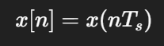
1. Sampling
The analog signal is measured at regular intervals.

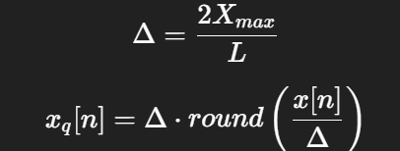
2. Quantization
Each sample is approximated to the nearest discrete amplitude level.
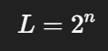
3. Encoding
Each quantized level is converted into binary bits.

Key Characteristics of PCM:
- Sampling frequency must satisfy Nyquist criteria
- Higher quantization levels → better signal quality
- Higher number of bits → higher bandwidth requirement
- Digital transmission improves noise immunity

4. PCM System Overview
Transmitter
Analog Signal → Sampler → Quantizer → Encoder → PCM Bitstream
Receiver
PCM Bitstream → Decoder → DAC → Low-Pass Filter → Reconstructed Signal
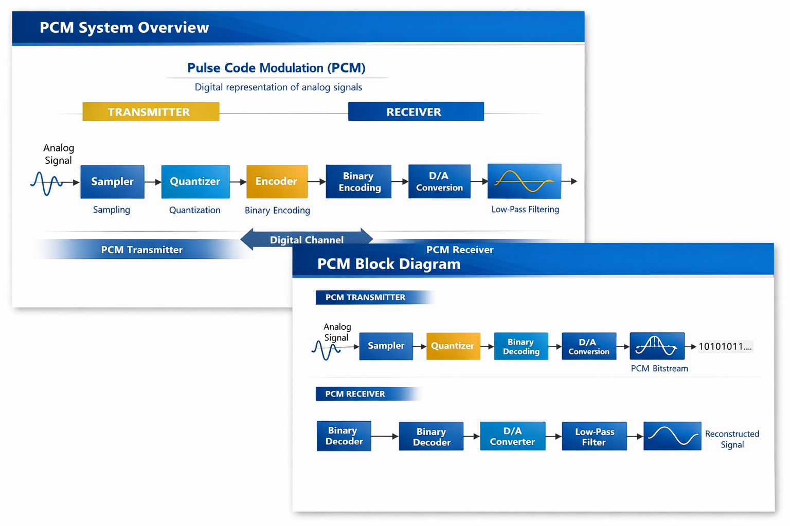
Figure 1: PCM System Overview

5. Design Specifications

Parameter | Value
Amplitude | 1 V
Message Frequency | 950 Hz
Sampling Frequency | 8000 Hz
Sampling Time | 0.000125 s
Quantization Levels (L) | 16
Bits per sample (n) | 4
Step size (Δ) | 0.125
LPF Cutoff | 2000-2500 Hz

6. Simulink Implementation
Step 1: Model Setup
- Open Simulink → Blank Model
- Set Stop Time = 0.02 s
- Use Fixed-step solver
Step 2: Input Signal
- Add Sine Wave block
- Amplitude = 1
- Frequency = 950 Hz
- Connect to Scope → Input Signal
Step 3: Sampling
- Add Zero-Order Hold
- Sample time = 0.000125 s
- Output → Scope → Sampled Signal
Step 4: Saturation
- Add Saturation block
- Limits = [-1, +1]
- Prevents overload distortion

Step 5: Quantizer
Implement using:
- Gain (1/Δ = 8)
- Round
- Gain (Δ = 0.125)
Output → Scope → Quantized Signal
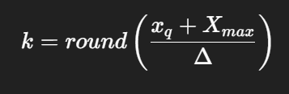
Step 6: Index Mapping
Use:
- Sum (+1)
- Gain (8)
- Round
- Saturation [0–15]
Step 7: Encoding
- Use Integer to Bit Converter
- Number of bits = 4
- Output → Scope → PCM Bits
Step 8: Decoding
- Use Bit to Integer Converter
Step 9: Reconstruction
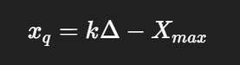
Use:
- Gain (0.125)
- Sum (-1)

Step 10: DAC
- Add Zero-Order Hold
- Output → Scope → DAC Output
Step 11: Low-Pass Filter
- Use Transfer Function or LPF block
- Cutoff = 2500 Hz
- Output → Scope → Reconstructed Signal

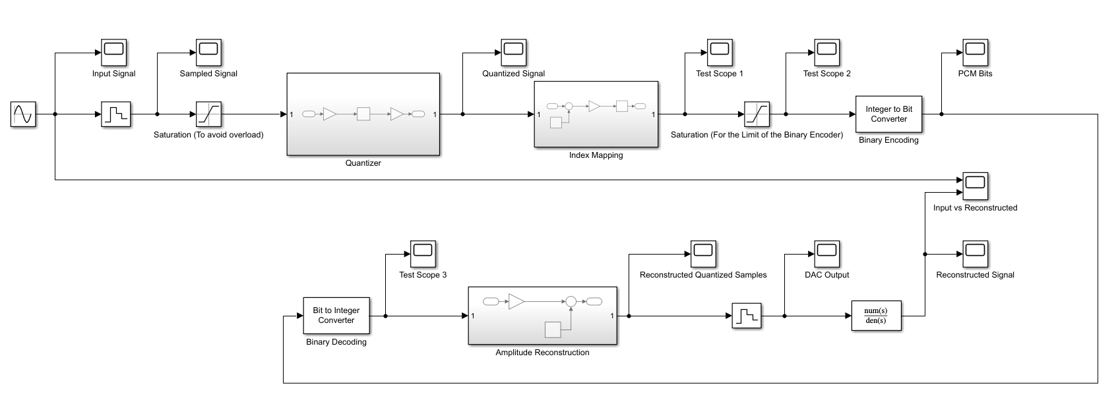
Figure 2: Simulink Solution

7. Results and Discussion
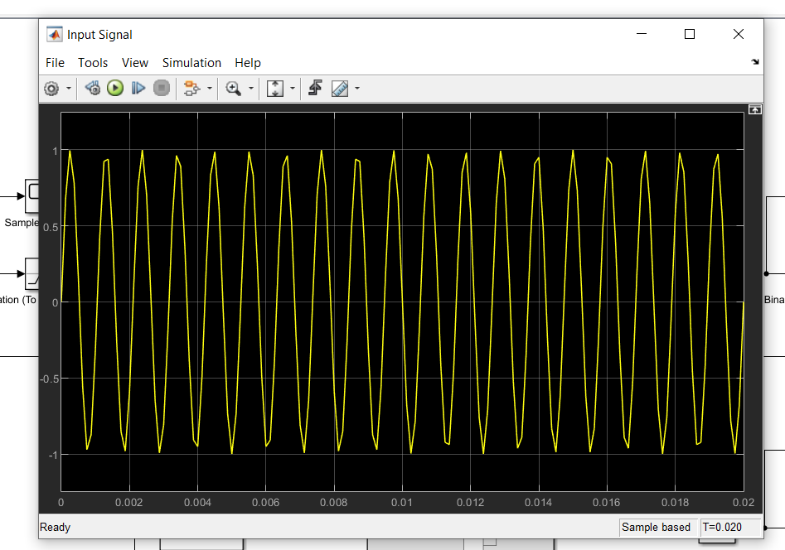
Figure 3: Input Signal
The input signal is a continuous sinusoidal waveform representing the original analog signal. It has a smooth shape with constant amplitude and frequency, serving as the reference for comparison.
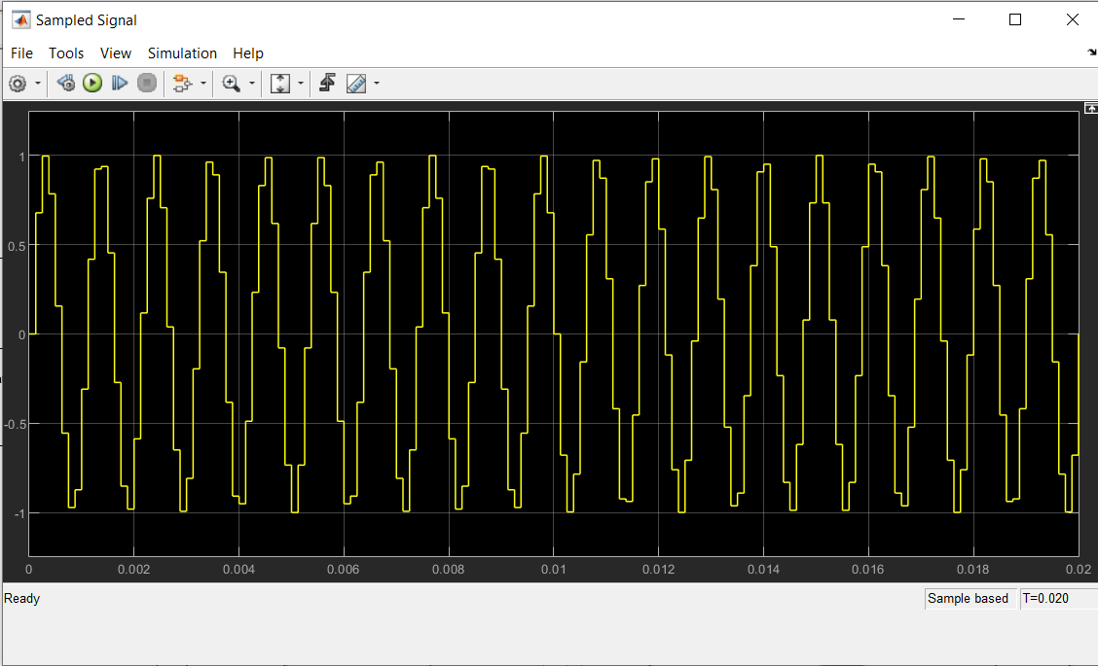
Figure 4: Sampled Signal
The sampled signal shows discrete-time samples of the original signal obtained at a sampling frequency of 8 kHz. The waveform appears as a staircase-like signal, confirming proper sampling using Zero-Order Hold.

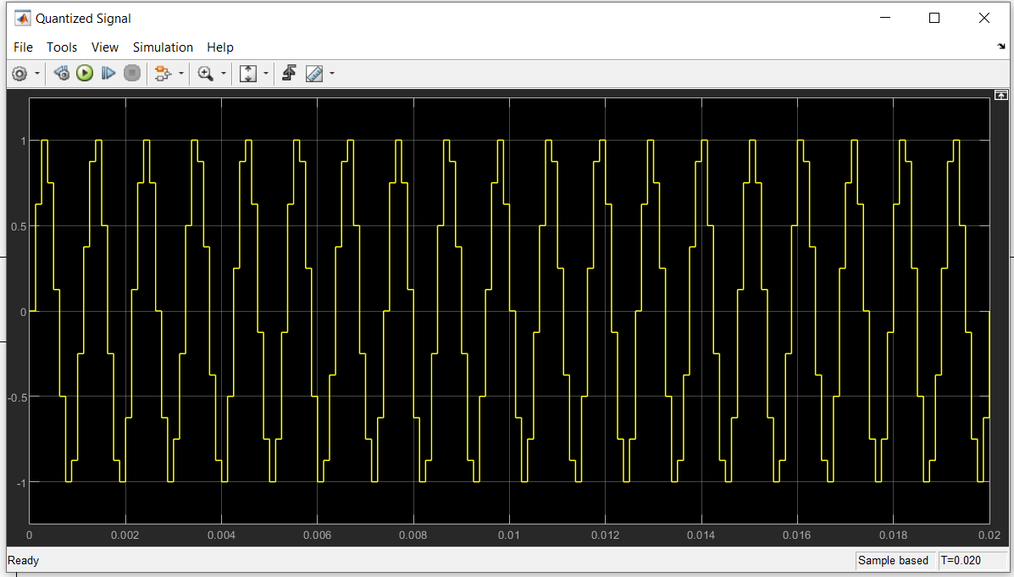
Figure 5: Quantized Signal
The quantized signal displays discrete amplitude levels, where each sample is approximated to the nearest quantization level. This introduces small errors compared to the original signal, known as quantization noise.
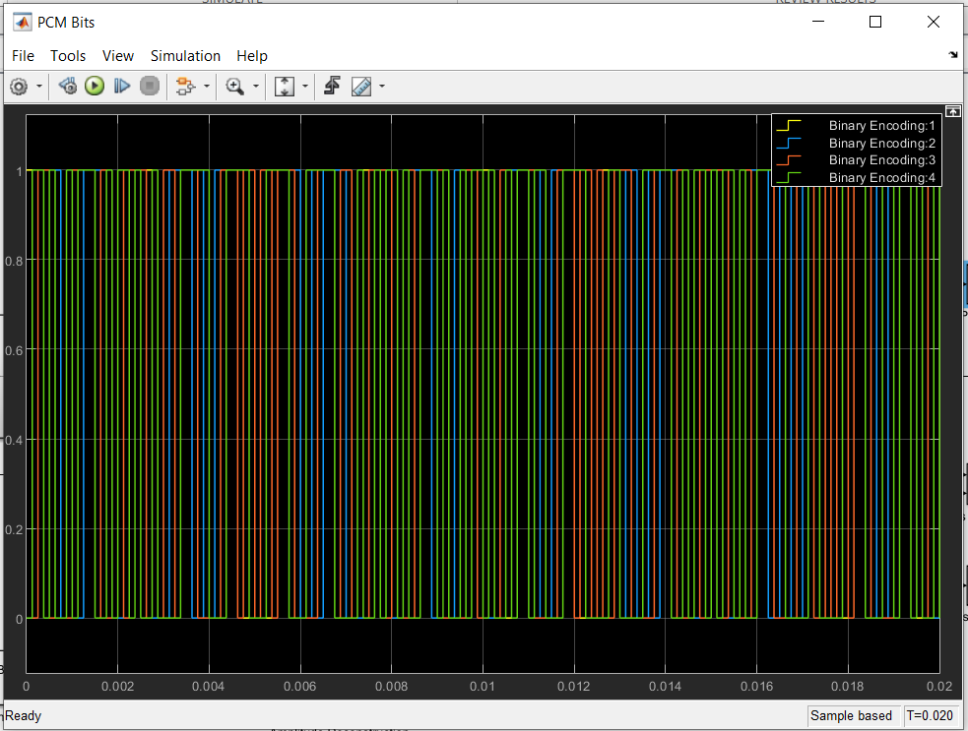
Figure 6: PCM Bits
The PCM bitstream represents the digital encoding of the quantized signal using 4 bits per sample. The signal consists of binary sequences (0s and 1s), confirming successful conversion from analog to digital form.
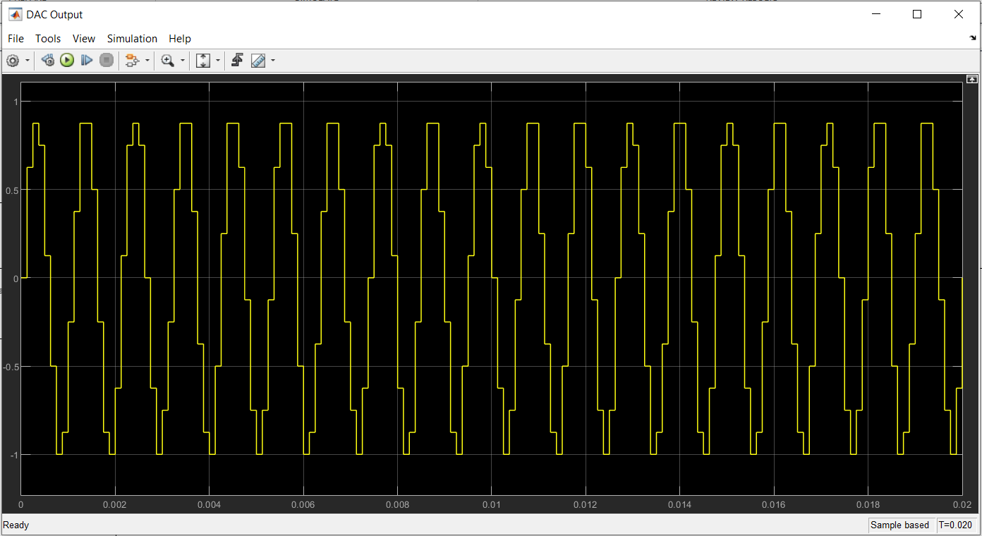
Figure 7: DAC Output
The DAC output shows a staircase waveform generated from the decoded digital signal. This signal approximates the original waveform but contains sharp transitions due to discrete reconstruction.
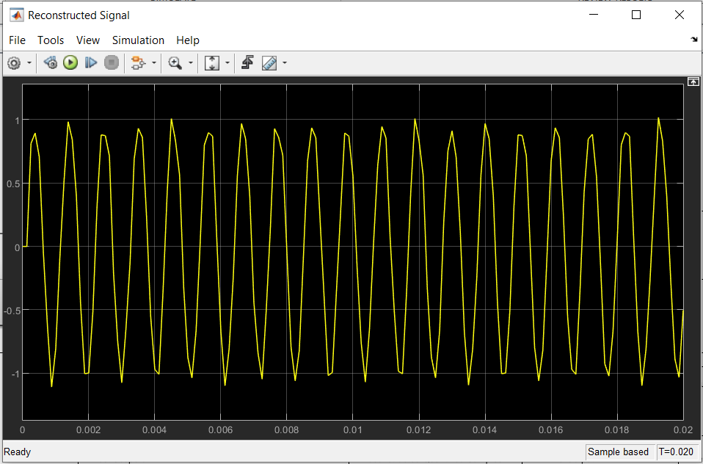
Figure 8: Reconstructed Signal
The reconstructed signal is obtained after passing the DAC output through a low-pass filter. It closely resembles the original sinusoidal signal, with minor distortions caused by quantization and filtering effects.

The system successfully converts the analog signal into a digital PCM signal and reconstructs it at the receiver.
Observations
- The sampled signal is discrete in time
- The quantized signal shows amplitude levels
- PCM output is binary
- DAC output is a staircase waveform
- Low-pass filter smooths the signal
Input vs Output Comparison
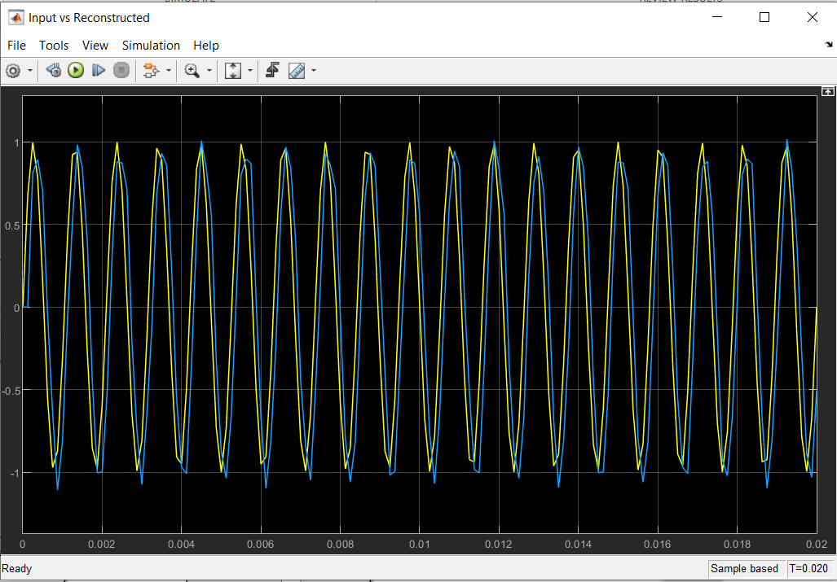
Figure 9: Input vs Reconstructed
The comparison shows that the reconstructed signal closely follows the original input signal in both shape and frequency. A slight amplitude difference and small distortion are observed due to quantization noise and filter attenuation.
This confirms correct system operation.

8. Quantization Noise Analysis
- Quantization Error: $e[n]=x[n]-x_{q}[n]$
- Noise Power: $P_{q}=\frac{Δ^{2}}{12}$

Types of Quantization Noise:
- Granular Noise
Small error within quantization range
- Overload Distortion
Occurs when signal exceeds allowed range
- Correlated Noise
Produces harmonic distortion in periodic signals

Noise Reduction Methods:
- Increase number of quantization levels
- Avoid overload using saturation
- Use non-uniform quantization (μ-law, A-law)

9. Performance Evaluation
Formula: $SQNR=\frac{P_{s}}{P_{q}}$ $SQNR_{dB}=10{log⁡}_{10}\left(\frac{P_{s}}{P_{q}}\right)$
For L = 16:
- Δ = 0.125
- Signal power ≈ 0.5
- Noise power ≈ 0.0013
- $SQNR≈26\text{ dB}$
Effect of Quantization Levels
L | Bits | SQNR
8 | 3 | ~20 dB
16 | 4 | ~26 dB
64 | 6 | ~38 dB
256 | 8 | ~50 dB

  - Increasing bits improves SQNR (~6 dB per bit)

10. Advantages and Disadvantages
Advantages:
- High noise immunity
- Suitable for digital systems
- Easy processing and storage
- Supports error correction
Disadvantages:
- Requires high bandwidth
- Quantization noise exists
- More complex system design

11. Future Work
- Implement μ-law or A-law companding
- Test using real audio signals
- Add channel noise (AWGN)
- Compare with DPCM and Delta Modulation

12. Conclusion
In this project, a complete PCM system was successfully designed and implemented using MATLAB Simulink.
The system demonstrated:
- Sampling
- Quantization
- Encoding and decoding
- Signal reconstruction
The results showed that increasing quantization levels improves signal quality and reduces noise. The reconstructed signal closely matches the original signal, confirming the effectiveness of PCM in digital communication systems.

References
1. S. Haykin, Digital Communication Systems, 1st Edition. Hoboken, NJ: John Wiley & Sons, 2014
2. J. G. Proakis and M. Salehi, Digital Communications, 5th Edition. New York: McGraw-Hill, 2008
3. MathWorks, "Simulink Documentation — Zero-Order Hold, Quantizer, and Communications Toolbox," MathWorks, 2024. [Online]. Available: https://www.mathworks.com/help/simulink/
4. International Telecommunication Union, "ITU-T Recommendation G.711: Pulse Code Modulation (PCM) of Voice Frequencies," ITU-T, Geneva, 1988 (revised 2000). [Online]. Available: https://www.itu.int/rec/T-REC-G.711/

